Darlo Dash Route Description
Walworth Gate to Piercebridge (5.5 miles)
Refreshments available: Piercebridge Farm Shop
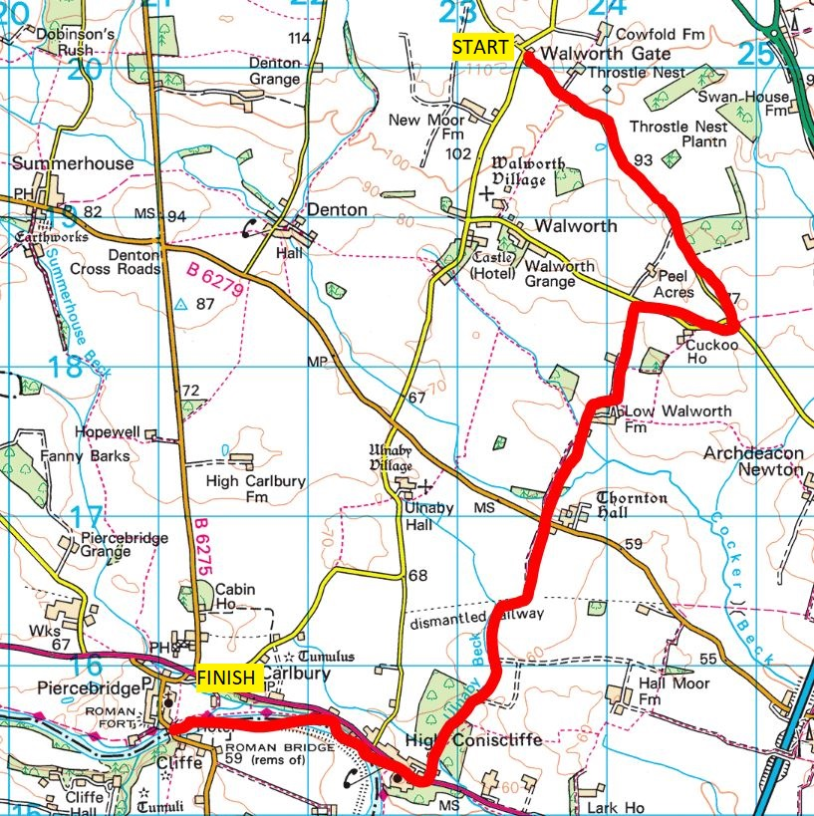

From Walworth Gate, head along Back Lane towards Darlington for 1 mile until you reach a T-junction. Turn right and run down and up a dip. Follow the road past a house on the left as it bends to the right, for another 200m until you reach a sign for Low Walworth Farm on your left. Take this track. After 500m the footpath winds its way around farm buildings and cottages. You need to follow the track to the right as it bends around a renovated farmhouse and garden. Do not go straight on as this is a dead end. There is a footpath sign you can follow.
Keep on the main track (suitable for cars and farm vehicles) and ignore any other paths to the left or right. After another 500m you pass some trees and come to a road. Go straight across and pick up the farm track/ footpath on the other side. After the first field, the path turns sharp right. Continue along this obvious path between the fields and follow the path as it veers to the left. You will have woodland and a beck on your right-hand side and a field to your left. Keep going straight ahead after you have left the woodland, don’t take a turn to the right. After another field, you will enter another wooded area with trees on both sides. Go through a gate and keep to the footpath going straight ahead and ignore any paths off to the sides.
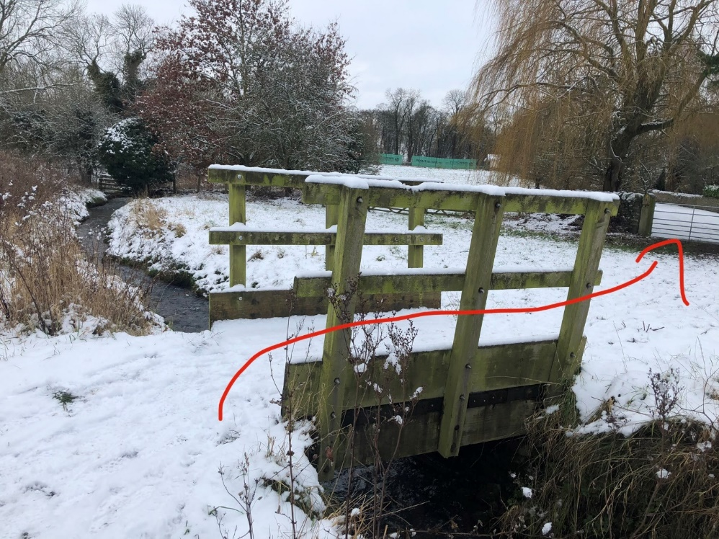

Cross over a footbridge and then through a metal gate with a house on your right. Carry on along the tarmac, passing tennis courts on your left until you reach the end of the lane.
Once you got past the tennis courts, turn right along the A67, past the Spotted Dog pub and all the way through the village. Carry on after leaving the village for another 300m until you pass a couple of cottages. Immediately after the cottages, look for a path down between the trees on the left-hand side. Take care when crossing the road.
Follow this path steep down into the woods. The path meanders through the woods and over a footbridge before emerging in a field. The path continues through the field, close the riverbank, passing through a couple, of metal kissing gates. There is a little dip shortly before a farmhouse appears on the right, with a wall ahead on your left. Take the stile (stone steps leading to a little gate on the wall) through the wall and keep to the left of the field, heading directly towards the Bridge and the village of Piercebridge ahead of you. Go through the wooden gate out of the field. Head under an archway next to a pink house and you will see steps on the left. Go up the steps to emerge on the road, with the bridge over the Tees on your left. Cross the bridge and keep going along the road, passing the George pub and hotel.

Piercebridge to Cleasby (3.65 miles)
Refreshments available: None after Piercebridge
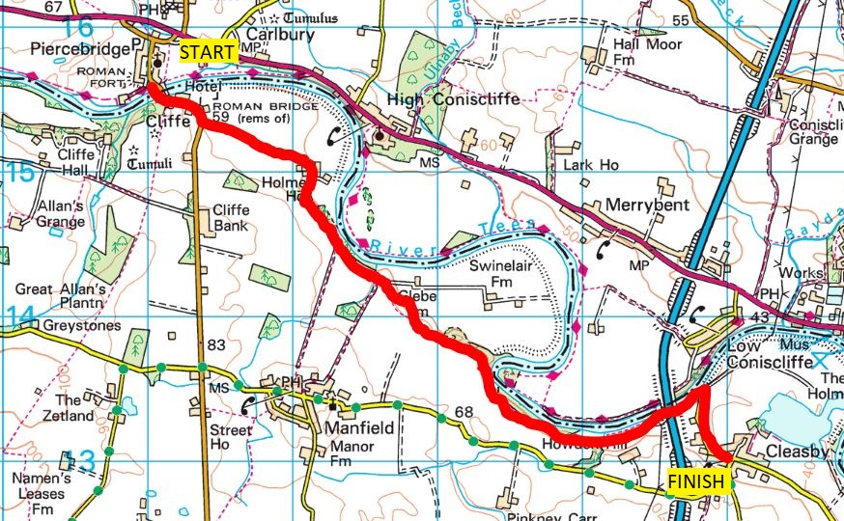

After the George pub you run past a car park for the Roman Bridge, and the road veers to the right. After the corner and house, you should see a sign for The Hut B&B on the left that takes you over a cattle grid and onto a private tarmac road. Follow this road until you reach a collection of houses at the end on your right. The path turns right along the drive and goes between the houses and some garages to a new gate. Go through the gate and follow a track through the field, bearing right and sweeping in an arc to get you to the top of the hill behind the hedge ahead of you.
Follow the path along the side of the fields, with woodland on your left. After 300m you’ll see a sign for a path on the right, ignore this one and carry on alongside the trees and river. This path ends on a private farm road. Turn right uphill and after 20m look for a fairly concealed footpath on the left side of the road between some trees. Climb up the bank to enter the field. Stick to the top of the field, the path runs on quite a camber all the way through the field to reach a gate in the top far corner.
Run through a short (muddy) woodland section until you come to a gate. Just before that gate, look for a stile on the left. Go over the stile and run down the field ahead. Make sure you have the trees on your right-hand side and not the left side, or you are running down the wrong field! The footpath has signs, so follow these. For the next mile or so, the trail has a couple of twists and turns but generally sticks to the edge of fields, with trees to your left and the river beyond. After that mile, the path veers slightly away from the river and takes you through a sheep field. You go down a steep slope.
There is a green footpath sign for Cleasby that takes a sharp left. Keep the trees and stream on your right and don’t go through the metal gate ahead. When you get close to the river you need to turn right and ford the stream, and take a footpath with fences on either side. The path continues under a bridge (under the A1) and at the end of the next field, turn right onto a road. After passing between farm buildings you will get to the village of Cleasby.

Cleasby to Neasham (6.25 miles)
Refreshments available: Various pubs, Fish and Chips at Hurworth
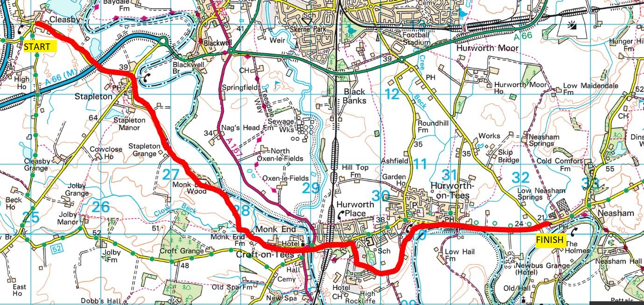

From the village green, carry on along the road (signposted for Stapleton and Darlington). Continue along the road until you reach Stapleton. Turn right at the T-junction into the village. Navigation gets a bit easier, as you are now following the Teesdale Way for the next 10 or so miles. From the village green, follow Strawgate Lane.
After the last houses on the left side, go into a field on the left side of the road and cross the field in a roughly diagonal direction. At the other end of the field you’ll see another Teesdale Way sign, pointing up along the road to the left. Head up the road for 500m. Where the lane veers to the right, keep straight ahead, passing a barn/ stable building. The footpath continues along the crest, with woods down to the river on the left and fields on the right. After about a mile the path veers to the left and steep down the (muddy) bank. The path becomes a farm lane, passing Clow Beck House along the way. Pass through a gate and onto S. Parade, passing through Croft. When you pass the church on your left, continue straight ahead, over the bridge over the river Tees. Once over the bridge, you have gone from Croft to Hurworth Place.
Take Hurworth Road immediately after the bridge, up the hill that becomes gradually steeper. Stay on the right-hand side of the road. Once you are over the railway bridge, carry on for 150m. You will pass a lane with the interesting name of “Peaceful Valley”. After that, take the next lane on your right, opposite Grange Ave on the other side of the road. This lane passes the back of various houses and a woodland on the left, for 250m. You come out in the grounds of Rockliffe Hall.
Cross a road and carry straight on along a signposted footpath, with the Hall on your right and a cricket field and pavilion on your left. Cross another road towards the Hall and carry on straight ahead. Follow the footpath until it terminates with a gate. You come out of the hall grounds and onto farmland. Cross two fields to reach Blind Lane, and turn left along the road,
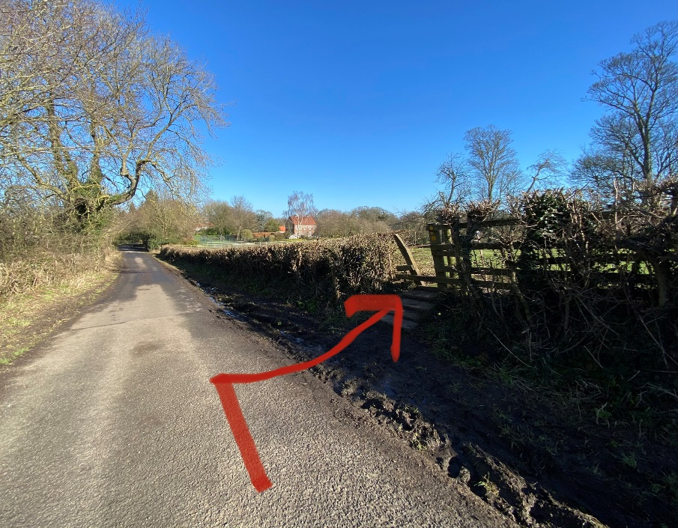

After 400m, look for a well-hidden stile in the hedge on the right-hand side. Go over the stile to cross a field diagonally downhill. At the bottom of the hill you’ll see a gate on the left. Go through a couple of gates along the footpath between the houses. When you reach the road, turn right and you will come out on the green at Hurworth-on-Tees. Carry on straight along the road for about 1.5 miles, to reach Neasham.

Neasham to Middleton St George (6.35 miles)
Refreshments available: Shops, pubs and cafes at Middleton St. George
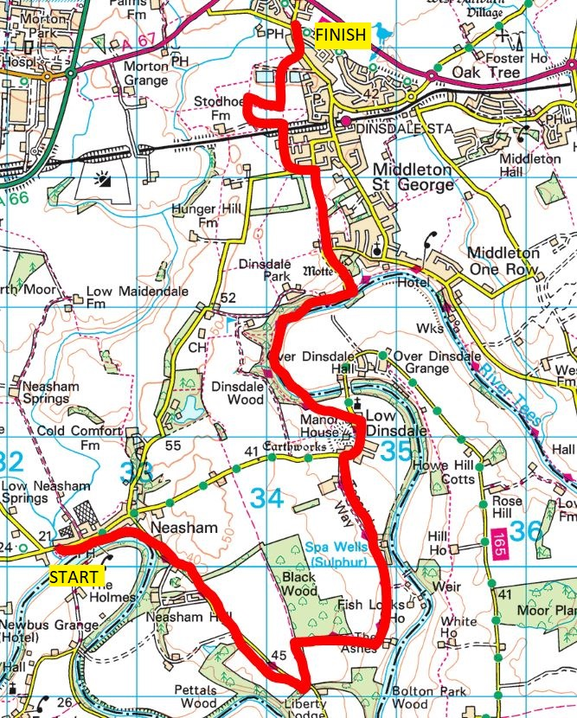

Mandatory section: You have to follow the Teesdale Way loop down and around Black Wood. If you shortcut and use the direct road from Neasham to Low Dinsdale your Dash will not be recognised officially.
When you reach Neasham, look for a signpost for the Teesdale way on the right side of the road. Follow this raised footpath for 300m as it skirts along the back of houses and playing fields beside the river.
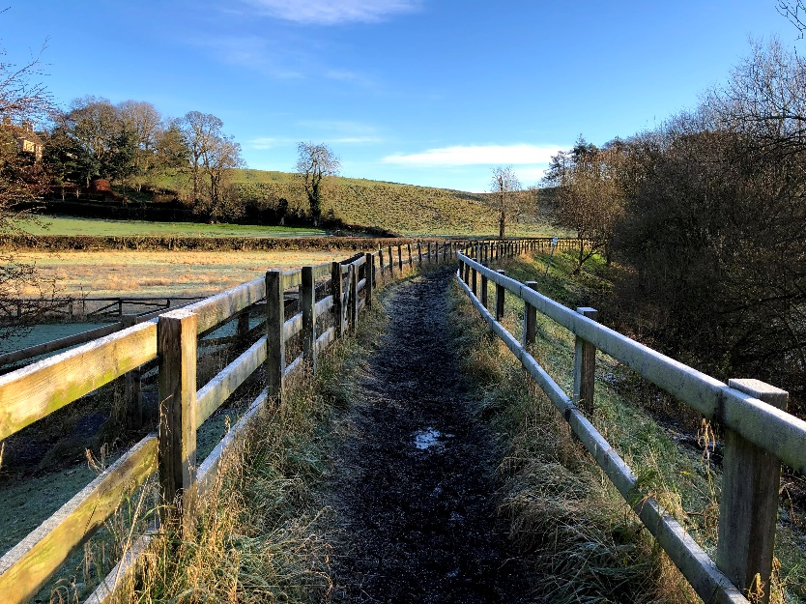

After the houses, the path veers to the right and then left to climb onto the quiet road between Neasham and Sockburn. Continue along the road for 1.5 miles. When you come to some woods, the road curves ahead to the right, and you want to take the Teesdale Way which comes back off the road and onto trails, sharp left. After 250m, look out for a concertina stile on your right-hand side. Go through the stile and down the grassy meadow, with the woods on your left. At the bottom, through another gate and the path becomes a tarmac drive. Pass “The Ashes” on your right and follow the drive as it veers to the left and uphill past a drive signposted “Old Fishlocks House”. Continue along this drive for 1 mile until you reach the road.
Turn right and follow the road past Manor House farm on your right, and keep on the road until it curves to the left, with the church and rectory ahead. From here, take the Teesdale Way through the field on your left. Cross the field more or less diagonally, aiming for a stile that takes you into the woodland ahead. Carry on through the woodland for 1 mile. There are a couple of junctions on this path - at each of these, keep to the path on the right-hand side. As you come out of the woods keep to the path close to the river to skirt around a house and garden. As you run along the grass there is a drive on your left. Run on the drive and it will veer sharply to the left.
Go up Church Lane, and after 300m where the road turns to the right, head straight on along Roman Way. Keep straight on, passing through a gate and continue straight on through a field. At the end of the field, turn left onto Neasham Road for 150m. Take the lane on your right. Run along the length of this lane, passing a house and stables on the left and a pond on your right, before crossing over the railway and a stile.
Route diversion (March 2021, for 6 months): The footpath at the end of this field is currently closed. Once you have gone over the stile, run across the field diagonally to the right, aiming for a stile at the edge of the field, between houses. Keep going along a very narrow path between back-garden fences, crossing over one road and carrying on along the path until you reach Station Road. Turn left and follow Station Road all the way through the village.
At this point you want to be running in the same direction (due north), but construction works means the direct path is fenced off. Turn left and follow the fence around. There are signs to guide you around the diverted footpath which are more or less helpful. Maybe less than more! But on the other side you should pick up an obvious path that takes you to a stile. Cross this and you’ll come out opposite some lakes. Go straight ahead on the path between two lakes. On the far side of the lake head keep in the direction you are heading, down and over a stile directly ahead. Head diagonally to the right through this field, aiming for a stile in the top right-hand corner. Turn left onto Station Road and continue for 150m.
When you see the Platform One pub, take the Sadberge Road, and immediately after the pub take the footpath on the left.

Middleton St George to Sadberge (2.7 miles)
Refreshments available: Pubs in Sadberge village

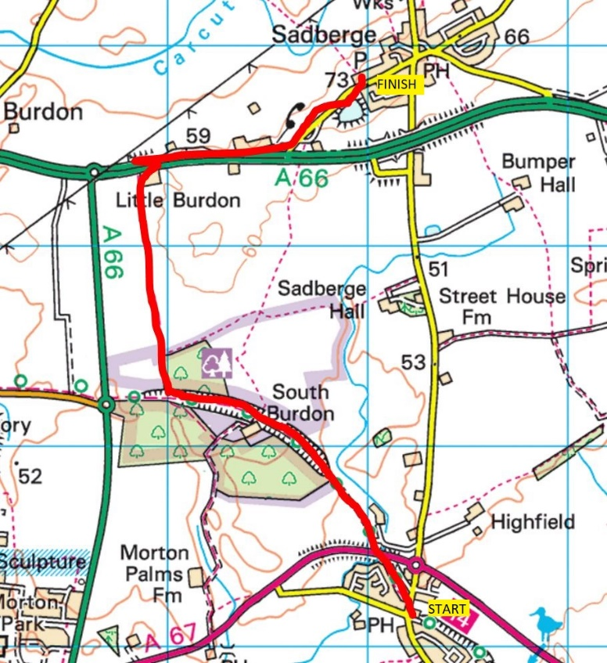

After passing under a road bridge, carry on along this well-made path for about another mile. Just before the path gets steeper uphill (to cross the A66 back into Darlington) you’ll see paths on both left- and right-hand sides (you should see a sign for South Burdon Community Woods on the left). Take the path on the right, up along a field.
At the top where the path looks like it turns to the right, look for a gate that is a bit hidden in the trees to the left. Go through this gate and then another one shortly afterwards and follow the path northwards. You will cross 2 or 3 fields with horses, just keep to the right side of the field. One field does not have a stile so you need to climb over the fence (watch out for nails on the other side of this fence!). You are still on the public bridleway, this is fine. Finally, you go through a rough meadow, with an abandoned farmhouse on your right.
Go through the gate at the end here and turn right to follow the track under the A66. Turn left up the bank, and then turn left again to run alongside the busy A66 for half a mile. As soon as you see houses on your left follow this road away from the A66 and up into the village of Sadberge.

Sadberge to Brafferton (5.25 miles)
Refreshments available: None
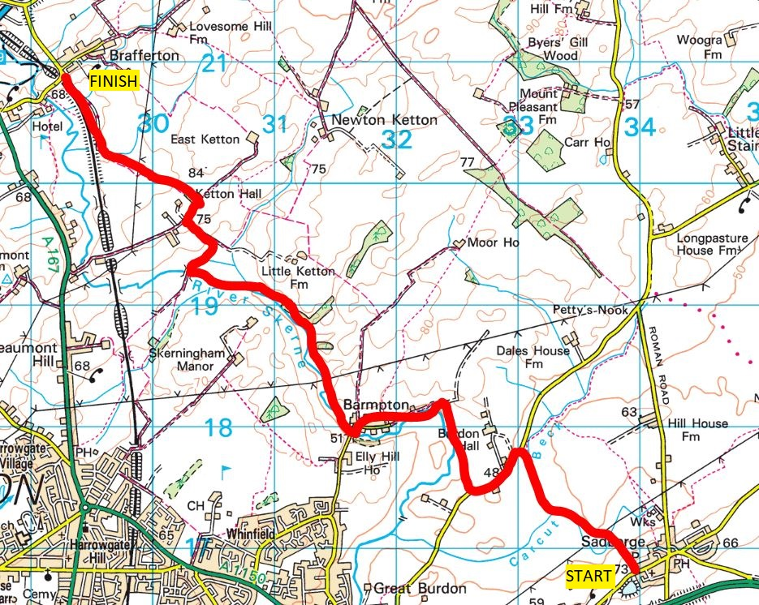

Brafferton lies a few miles north-west of Sadberge. There are numerous paths and available routes between the two. I have found this particular route works well but do try alternatives and let me know how you get on. One I’d like to revisit takes a path further east (Catkill Lane) but it was pretty much underwater for a mile when I tried it.
As soon as you reach Sadberge there is an ornamental garden on your left followed by the village hall. Take the public footpath through the side gate on the left that runs down the side of the village hall building. Follow the path down the side of the field, over a stile and into another field. Head for the footbridge diagonally to the left. Continue straight on with a beck on your left (this may not be immediately visible but will be more obvious further on). Pass a large pylon on your left and after 600m cross a footbridge on your left, and turn right to follow the side of the field until you reach the road. Turn left and run alongside the road. Care is needed as cars go fast along this road.
After 500m there is a small layby on the right side of the road and a stile and footpath ahead. Follow this footpath for 800m, crossing a couple of stiles. Towards the end of this section the stile is fairly hidden bearing right to the corner of a field. There is a farm track ahead, turn left and follow this track that takes you to Barmpton. Once you pass a gate the path turns into a road. Follow the road for 300m until it turns sharply to the right – ignore two footpath signs on the right hand side as you run through the village. Just after the bend, look for a footpath/ kissing gate on your right, next to some trees and a bin. Follow this path for 1 mile, going through various gates on the way.
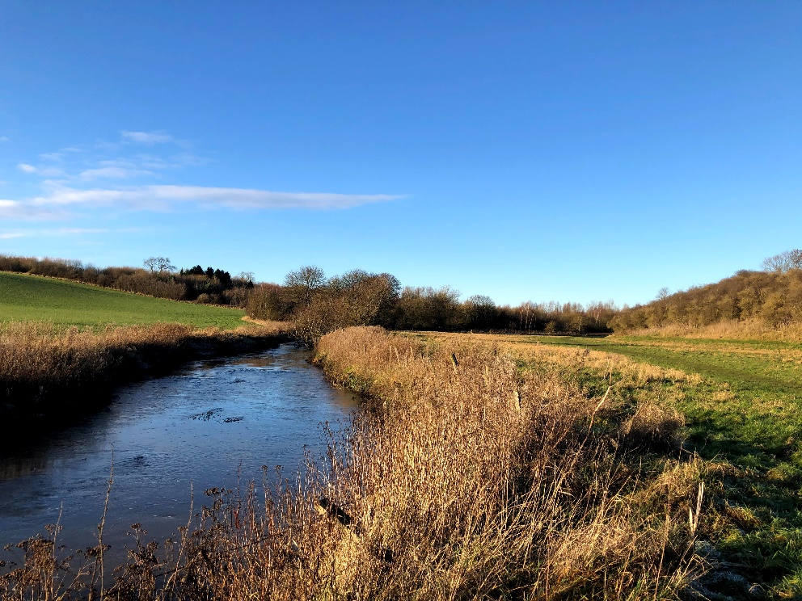

A general rule of thumb - keep the river Skerne on your left-hand side. You will come to a bridge over the river, and a disused packhorse bridge. Don’t go over the bridge, but turn right along the farm track (don’t take the first track to the left up to a farm, the farmer won’t be happy) and follow this path for 400m until you reach a tarmac road. Go left up the hill and at the end of the road turn right. Carry on past Ketton Hall and in the first field on your left, go through (brand new) metal gate. Follow the trail with the trees and property on your left and then downhill along the edge of the field. The bridleway veers for 1km through various fields on the way down to finish at a gate with the railway embankment on your left. Go along the track for 500m, you can either carry on straight or slightly to the left there is a signposted path through the woods. At the end, you will either have a steep incline, or a set of steps that take you up to road level, just beside the railway on your left and the village of Brafferton on your right.

Brafferton to Heighington (3.8 miles)
Refreshments available: Pubs, takeaway and shops at Heighington
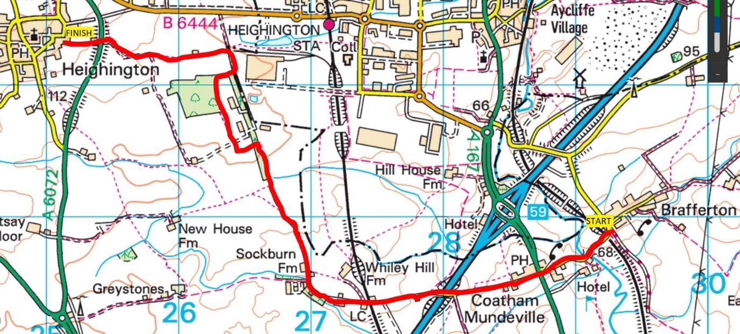

This is another section with multiple options to get from one village to the other. Unfortunately, some of the footpaths here are not in the best condition either, and navigation-wise this is the trickiest section of the Dash.
I have found six viable routes for this section that all have their good and bad sides, so if you are familiar with this area just go with what you know. The criteria here is that you start in Brafferton and finish in Heighington. The options are as follows:
- Via Cumby’s Plantation (see full description below). Upsides: this is a nice direct route with variety. Downsides: there are two sections which are very overgrown (possibly unpassable in Summer) and one short section that goes through a clay pigeon shoot area.
- Via Brakkes Farm. Upsides: a nice direct and scenic route. Downside: the footpath through the farm is currently diverted and not signposted so you are likely to get stuck in a field, and potentially with some nosy alpacas!
- Via New House Farm. Upsides: navigation wise not too tricky. Downsides: The point where you cross the A6072 is not as good as the routes above and the fields either side of the road are awful to the point of being unrunnable.
- Via Greystones Farm. Downsides: this is good up until you reach Greystones. The path northwards from there is very vague and then you have the same problems was with route #3 with the A6072
- Skirting the motorway. This takes a footpath on the right just after crossing the motorway bridge. You then go through a couple of fields and along a track besides Aycliffe Industrial Estate. Downsides: The farmer has blocked the path between two fields so you need to do a bit of climbing. Also there are some very rough (overgrown/ flooded) patches on the path adjacent to the first industrial units you come to.
- Via road, from Brafferton through Aycliffe Village/ Aycliffe Industrial Estate/ Heighington Station. Upside: You avoid a very muddy section (arguably this is a downside!). Downside: It will add some distance to the run, and the surroundings are not the most inspiring.
From the railway bridge adjacent to Brafferton, turn left, down the road to reach Coatham Mundeville. Continue past Hall Garth Hotel, and up to reach the Foresters Arms and the busy A167. There are crossing points to get over the road, but this road is VERY BUSY with fast traffic so extreme care is required. Continue along the lane through Coatham Mundeville, passing over the motorway and a level crossing. The road turns into a track. Continue straight on, ignoring a track to the right (signposted for Whiley Hill). As the track veers round to the right keep on this main track, ignoring another track off to the left. Go through the farmyard of Sockburn Farm, and through a gate. Carry on along the very muddy lane for another 500m, looking out for a footpath sign on a gate on the left. Cross the stile, and keep to the right side of the field, along the hedge. At the bottom of the field, you will pass through a hedge and over a stile into another field, with some woods ahead.

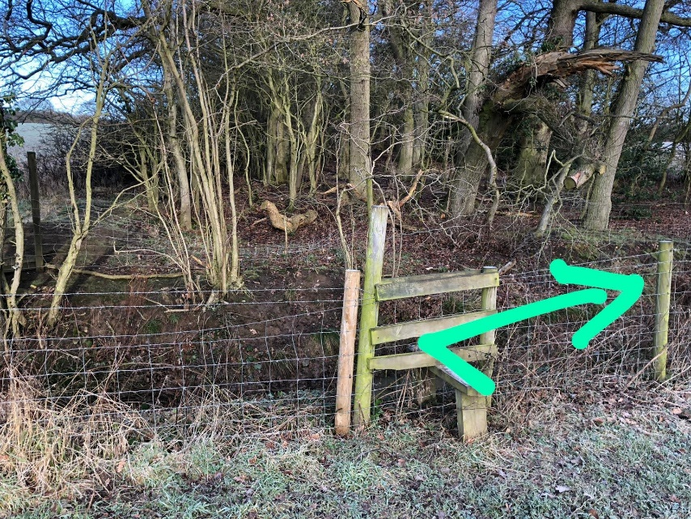

Straight ahead of you is a stile. Cross the stile, and go right along the bank of the stream for 20m. Turn left through some trees and you come out of the woods at a gate with a footpath sign.
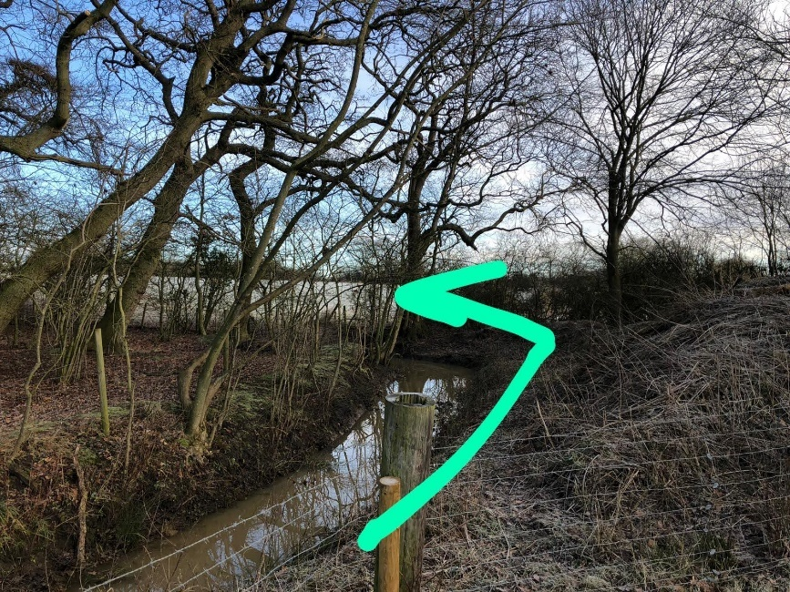
Follow the footpath signs as you climb up a field. After a line of trees the path goes back into the woodland, following the fence line. This is quite overgrown but passable – immediately after the stile there is a tree that almost blocks the path so you need to duck underneath or you may be able to hop over the fence just beyond. Again, look out for footpath signs and warnings about Clay Pigeon shooting (Note you can check when the clay pigeon club is likely to be open on their Facebook page: https://www.facebook.com/locomotiononeclaytargetclub). The path turns left, over a stile and along the perimeter fence of some WW2 defences including a couple of pillboxes. The path is signposted, turning right after 100m and continuing along the bottom of the clay pigeon shooting site. Go through a stile and into Cumby’s Plantation.
The going through the woodland is rough to begin with but continues straight ahead for 400m and then veers right on a much better path. Follow the path round to the left and along a track for 150m. You will see footpath signs on your right hand side. At this point go left through the field ahead. After 500m this footpath joins a farm track, carry on straight ahead. The track bears slightly to the right. Ignore trails heading off on both sides. Continue left to climb uphill to meet the busy A6072 road. TAKE CARE crossing the road. Go through a gate/ over the stile and field opposite, following the footpath that brings you to the village of Heighington.

Heighington to Walworth Gate (2.4 miles)
Refreshments available: None
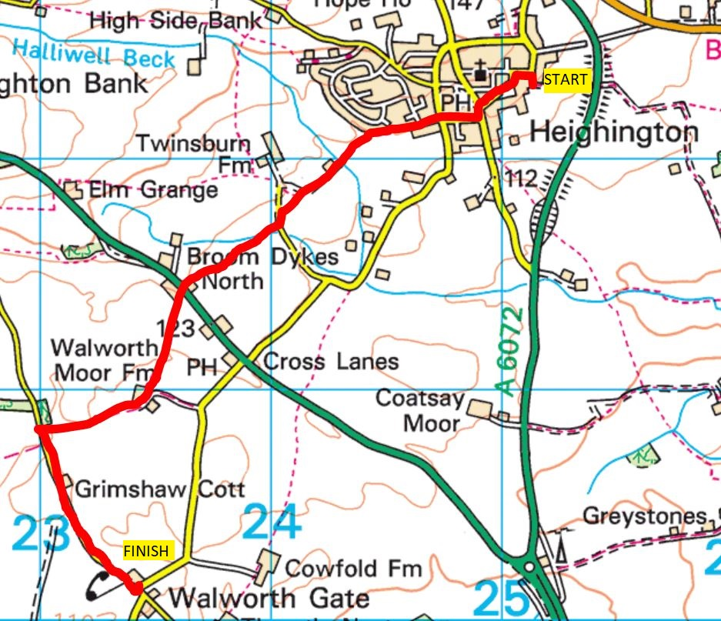

As you leave the field, follow the footpath through the houses until you come to a stone step of sorts. Turn left and follow the Station Road for 150m through the village green. Turn left onto Darlington Road and after 50m that the first road on the right (South View). Follow this road and straight on over the next junction. The road ends and a path continues, go along the footpath. After going straight on for 700m you come to a road with an HGV depot on your right. Go across the road onto a trail ahead with a beck on the left. After another 100m, the path crosses a footbridge on your left. Follow the path through a field – keeping note of the directions/ signs to avoid the private residence, bearing left and over a stile between a couple of paddocks with alpacas.
Go through a gate and come out on the busy A68. As always TAKE CARE crossing this road. Directly opposite is the mess that is Cock Inn Farm. There is a footpath sign to the left of the farm, but the owner of this farm does not feel the need to maintain this, so the start of the path is less obvious – head left and go over a gate (this may be obstructed by a farm trailer). After 50m, you’re in a long fairly narrow field. Head all the way to the bottom, aiming for a gate in the bottom left corner of the field.
Come out on a farm road, turn right and you will see a Walworth Moor Farm ahead. The footpath turns left, through a gate just before the farm into the field, just next to the entrance to the farm’s back garden (don’t go into the garden). It is not signposted. Veer right over a small hill and head down through the field keeping the hedge close on the right-hand side until you come to 3 gates at the bottom of the field. Take the middle gate and keep going ahead for 500m until you emerge on a minor road. Turn left, and you are on the final stretch back to Walworth Gate. After 800m, you are at the road junction at Walworth Gate, where this guide started. Darlo Dash done and dusted!

Nighttime
Some of the route will be fine whether you do it day or night. There are places where you cross farmyards and livestock fields, which I don’t recommend you do in the dark out of respect to the local farmers, and to keep us runners out of their bad books! Below are some notes to hopefully help you work out the timings of your run. Bear in mind this is only really relevant during the Winter months.
Piercebridge to Cleasby – There isn’t a good alternative route here. As you pass through a couple of farms and fields with livestock, you should not do this route in the dark. The only real alternative would be to follow roads between the two villages.
Brafferton to Heighington – The recommended route passes through the farmyard at Sockburn Farm so please don’t do this route at night.
Heighington to Walworth – The route passes close to a couple of farms/ through farm property so please don’t use this route at night. The road from Heighington to Walworth Gate is a good alternative, but there will be traffic to watch out for and the busy A68 to cross

