City & Coast Ultra

52 Miles 3000 feet

Start Location is Marsden Grotto Car Park, South Shields, NE34 7BS
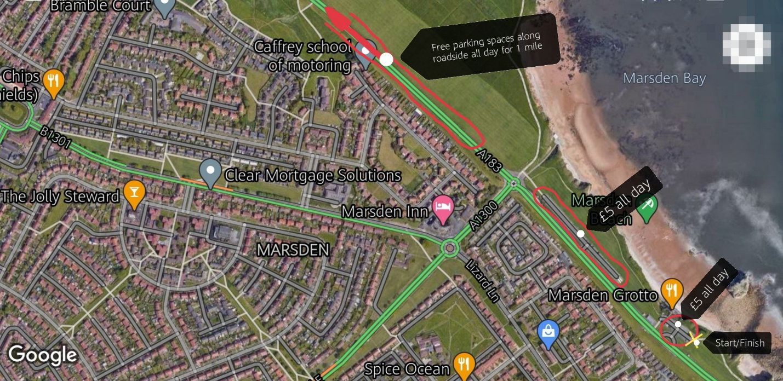

There is car parking available at start/finish also toilet blocks (unsure of availability at present), also more parking available a short distance from start at Marsden Beach Car Park. The nearest free parking spaces along the A183, Coast Road are about half a mile from start area then continue along roadside for approximately 1 mile.
OVERVIEW
A lovely route taking in a variety of paths, cycle routes and trails. Pretty flat route with gradual climbs making for the most part of the elevation. There isn’t much cover so on hot days you will be in the sun most of the time. Plenty shops on the route for restocking water and food noted in the description. Most of all just a lovely day out, so take care and enjoy and most of all have fun!
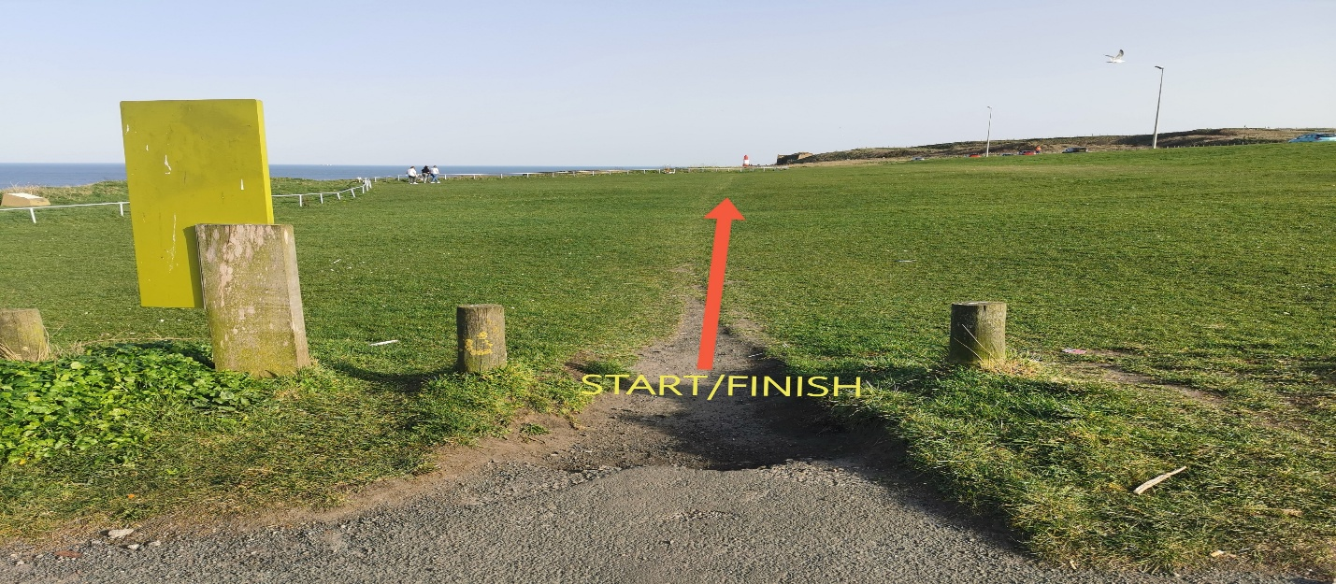
Route Description

The first 15 miles of route follows England Coast Path (ECP) /Acorn signs from the start to Noses Point just after Seaham.

Section 1 Marsden Grotto to River Wear - 5 miles

- Continue straight ahead between start/finish posts
- Upon reaching low railing stick to paths tight to railing
- After a short while bear left following obvious path down in front of the lighthouse
- Continue on the main cliff top path for approximately 2 miles
- When reaching the road continue for 10 metres then drop down to beach level then immediately back up to run along front of buildings
- Continue ahead then drop down to promenade & continue on low promenade around lighthouse then up the 2nd set of stairs
- Follow ahead sticking to left path
- Turn left at the acorn sign and descend from road to promenade
- Upon reaching promenade turn right & continue ahead until you reach the river Wear (5 miles)
- CAFES AND SHOPS AVAILABLE 4.5 MILES

Section 2 River Wear to Noses Point – 9.9 miles

- Follow the river inland after half a mile ascend road in front of you acorn signed at top of hill take path on left before petrol station
- Follow river till reach sign post pointing right acorn signed/C2C via Stadium of light follow road up hill and turn left across the bridge
- Take left immediately after bridge & descend back to River turn right and follow river
- After path leaves river turn left and follow road for a short while then turn right up stairs then left gradually up hill
- Cross road at sign post for Chance Community Centre and continue ahead across next road and enter Town Moor
- Turn right at acorn sign and exit Town Moor continue straight ahead along road to roundabout and turn left
- SHOP AVAILABLE AT 8 MILES
- Follow road ahead over 2 roundabouts and turn left at acorn sign
- Follow through tunnel don’t drop down to promenade but take left path that gradually descends then rises
- Pass car park turning left out towards cliff acorn signed
- Follow the obvious path as it winds along the clifftop descending down past a sign for Ryhope then back up on to cliff path
- Follow path along cliff then out onto road for a few metres then left at steps and back out to cliff
- Follow path till you arrive at some concrete steps turn right up steps then immediately left at top of steps out to the road then left acorn sign down to promenade
- Turn right and follow promenade for half mile before ascending ramp on your right up to road and continue ahead through Seaham
- SHOPS AND CAFES THROUGH SEAHAM 14 MILES
- Continue ahead on Coast road until you reach the turn off signed for Noses Point

Section 3 Noses Point to Ryhope - 9.8 miles

- Leave the coast road and head into the business park after a short while take the road on your right signed Dawdon Welfare Park and continue up hill through the tunnel
- At top of incline take left path signed public bridleway and continue ahead
- After crossing main road go between barn & House then head up hill through the red double metal gate
- Continue on main track ahead over rolling fields eventually passing some houses continue straight ahead cross busy road up the ramp and across the bridge over the A19
- Go right at roundabout downhill and turn left off road on to track signed South Hetton/Teesside
- After approximately 1 mile turn left across the road and follow track as it bears to the right
- Track turns to tarmac continue ahead until reaching pylon on your left and T junction turn left and continue straight ahead
- After passing barrier and rocks turn immediately right following fence line just before path rises turn left aiming towards telegraph pole and trail that enters the trees
- Exit the trees continue straight ahead on main wide track keeping allotments on your left eventually reaching metal gate and low wooden barrier signed Hawthorn/Ryhope Way
- Continue on Hawthorn/Ryhope Way for about 4.5 miles
- Cross road at traffic lights turn right and follow path until passing under old railway bridge then left off path onto road continue around to the left passing Railway Inn then cross road continue ahead passing The Albion pub on your right
- SHOP AT RYHOPE SLIGHT DIVERSION FROM ROUTE 25 MILES

Section 4 Ryhope to Cox Green – 8.8 miles

- After passing The Albion and The Forge garage on your right cross road up path signed Silksworth/City Centre
- Continue along path eventually passing yellow brick building on your right hand side and wheel monument on your left and continue straight ahead onto path with blue cycle sign
- After approximately 200 metres path forks take the right hand fork uphill staying on tarmac path and turn left at T-junction
- Just after passing the pub and 30 sign on your right there is a path up hill on the grass on your left go up there and just before brow of hill there is another path on your right that goes through a gap in the bushes take that path
- Continue ahead until reaching a car park the turn left up hill through the gap in railings and turn right head straight towards the Trig Point (stone pillar)
- Upon reaching the Trig Point turn immediately right and follow path down to track below and head left
- As the road splits right and straight ahead go straight on then as road bears to the left after 5 metres continue straight ahead off road and follow the path on your left around edge of field, down through the trees, around edge of next field and up the stupidly steep bank
- Upon reaching the track at top of bank turn right and continue ahead
- Cross 2 roads and enter the park as the path forks take the left fork and continue ahead passing The Ski Centre on your left straight ahead through car park taking path on your right at zebra crossing signed with blue arrow
- Follow path downhill to the pond then follow around pond to your left crossing road signed W2W cycle route then turn left signed Doxford International
- On reaching the road turn right signed Doxford International
- Follow main road around to the roundabout
- TESCO EXPRESS 30 MILES OPEN 06:00-10:30
- Continue straight ahead between The Board Inn and Methodist Church
- Turn right up Foxcover Lane then as the road turns right continue straight ahead ignore the left path after crossing A19
- Enter Herrington Park through the barrier and take right hand path following hedge line
- As the path ends turn right into the woods then take the path on the left into the field with the pylons in
- As the main track bears to the left continue straight ahead on the single track to reach the main road then turn left continue till the path runs out and cross the busy road and continue left to the roundabout
- Turn right and right again and run the steps to Penshaw Monument
- Continue ahead around the Monument past the Trig Point and take the steps on your left downhill continue left down through the gate and ahead on wide track
- Take the stile on your right continue diagonally down hill through field then follow path down to the road
- Cross road take wooden gate ahead over stile and follow feint path to the right across field and through gate
- After the green barn as path splits take left fork when reaching field turn immediately left follow the fence line down hill and down the steps to main path then turn right signed Cox Green continue until reaching the green bridge

Section 4 Cox Green to Greyhound Stadium – 7.3 miles

- Cross Bridge continue on road heading left then turn immediately right following C2C east sign continue up hill following public bridleway signed Pattinson ½ mile then continue straight ahead ignoring the cycle route 7 sign
- Follow main path as it winds round until reaching a car park turn immediately right along edge of car park and continue past entrance to Wetlands Centre onto small trail directly in front
- When small trail opens on to wide track continue to the right until track bears to the left signed Low Barmston Farm Don not turn left but continue ahead down a couple of steps and across a little bridge signed North Hylton
- Follow the trail till it reaches a T-junction turn right arrowed public footpath downhill over a stile and turn left keeping the wall on your right-hand side
- Continue along track until it turns to tarmac along the front of Shipwrights Pub then up hill on the road until it bears to the left then continue straight ahead signed C2C east, ignore next C2C sign
- Cross the road on your left where the 20mph signs are into Laburnum Grove then right at Almond Drive follow road around through the barrier and cross road into Fulford Grange stay on the main road through estate ignoring all left and right roads
- When you reach a black metal railing on your right with a litter bin attached to it turn right and go through railings
- Continue ahead on path and straight over path intersection as you approach a green metal barrier at the road take the path on your right and as that path bears to the left take the trail off to the right
- Straight over the next path intersection and follow trail all the way to the road just before reaching the road take the path on the left heading straight towards the castle
- Cross the road go through the barrier and take the right path downhill
- Follow this path eventually passing a pond on your right continue ahead up the bank and out on to the road
- Follow road to junction opposite Sainsburys and turn left up hill at top of road cross road heading right then cross again to get on left hand side of road (both of these roads are very busy advise crossing at traffic lights)
- Follow the path left along the front of the white bungalows until you reach the road and turn right
- Follow road until it turns right and cross to your left at the big CCTV camera go through the bollards and follow the metal fence when reaching the road continue straight ahead and head towards the shops that come into view
- SHOP 41 MILES ALSO SANDWICH SHOP AND CHIP SHOP
- Turn left when reaching the shops then right at the 3 concrete bollards
- Continue along path to the end then turn right blue cycle sign
- Follow path for a short while and as it turns right continue straight ahead through the bushes onto track then turn left when reaching some small yellow rocks on your left and follow path down side of field keeping bushes/trees on your right
- Follow track straight ahead as it turns to the right then the left and arrive at Sunderland Greyhound Stadium cross road and turn left

Section 5 Greyhound Stadium to Marsden Grotto Finish – 11.4 miles

- Continue left along the road in East Boldon eventually turning right down Grange Terrace past a hairdressers called Curl Up and Dye
- Follow road around to the left then right down path signed Public Bridleway
- When reaching the main road turn right signed West Harton/Temple Park
- Cross the train tracks then cross road left signed West Harton/Temple Park
- Follow path till reaching a crossroads then turn right signed The Coast 3 ½ miles then follow this path along back of houses ignoring the right turn then through some trees until it reaches the road
- Continue straight up the road and turn right signed Temple Park/Marsden cross the main road up the obvious path between the trees in front of you
- SHOP 45 MILES
- Cross the main road and continue ahead down the path to the right of the petrol station
- At the end of this path turn left and follow the road for 2.5 miles crossing straight over 3 roundabouts keeping on the left hand side of the road at all times until you reach the Town Hall then turn left downhill
- At the roundabout turn right continue up hill to the next roundabout and turn off signed Customs House
- Continue down the turn left heading towards Customs House the turn right and right again and start following the river side
- Follow the river along past the ferry until you have to turn right then left on to the road follow road for a short while past South Quays apartments sign then take steps across road on your right
- At top of steps turn left until reaching some more steps on your right go up these steps and turn left at the top
- Follow path along until crossing the road into Greens Place signed England Coast Path
- Continue straight along road passing tower Monument on your left then turn left downhill between the stone posts continue down then take steps on your left
- Cross road and continue straight ahead towards The Weebles (statues) head right towards the path in the corner then continue along the promenade turning left at the end down the pier
- Continue down the pier turning right at the England Coast Path sign then follow this path along the top of beach until it ends at The Leas sign then turn left towards England Coast Path sign follow this sign
- Follow ahead as the path rises to cliff top path turn left and follow the wide cliff top path all the way to the finish

THE END

