Barney Rumble Route Description

Piercebridge to Barforth Hall (Nr. Gainford) – 5 Miles
Refreshments: Piercebridge Farm Shop (check opening times)
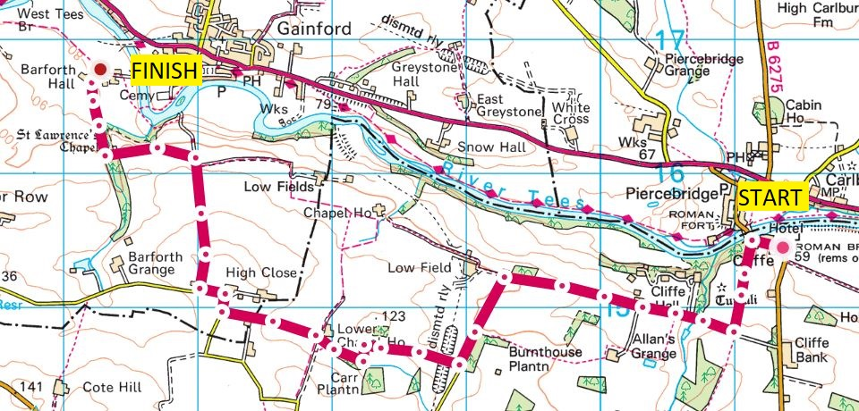
From the car park at the Roman Bridge, Piercebridge, head back towards Piercebridge, passing the George Hotel on your right. Just before the bridge, look for a footpath into the woods on the left side of the road.

Follow the path and after 50m, it veers sharply to the left, carrying on uphill and away from the river. Follow this path until you meet a kissing gate.

Continue straight ahead and uphill through two fields, passing through a gate. You will see a cricket pitch over on your right hand side.

At the top left corner of the field there is a stile over the wall that brings you out on a private tarmac road. Turn right and follow the road for 1km.

The road turns left – follow this and carry on along the road for 600m. When you have woodland on your left, look for a footpath off the right 100m further on.

Take this footpath for 800m. You'll reach a gate and the path then turns sharp left and down to a hedge. There is a sign that tells you the footpath continues on the far side of the hedge. The next section is 200m of muddy path through woods before emerging into a meadow with a house on your right. Keep following the path straight ahead keeping the house to your right and look for a gate in the corner.

Pass through the gate and cross the road to enter the field opposite. The footpath veers to the right and then left again on the far side of another hedge. Carry on along this path for 500m and through a gate. Keep going straight on - you will have horse fields to your right. The path emerges onto a road.

Turn right onto the road, down past the house at High Close and follow the road round to the left. After 100m turn right along the road signposted for Low Close and Barforth Hall.

Continue down the road for 800m. The road turns sharp left, with Barforth Hall signposted.

Carry on along this road and not the track dead ahead. Stop to admire the ruins of St Laurence's Chapel and a dovecote.

Follow the road as it veers round to the right, down and back up a steep dip. Carry on along the road down to the farm buildings and cottages around Barforth Hall.
Barforth Hall to Ovington – 3 miles
Refreshments: possibility of the pub being open in Ovington, otherwise none
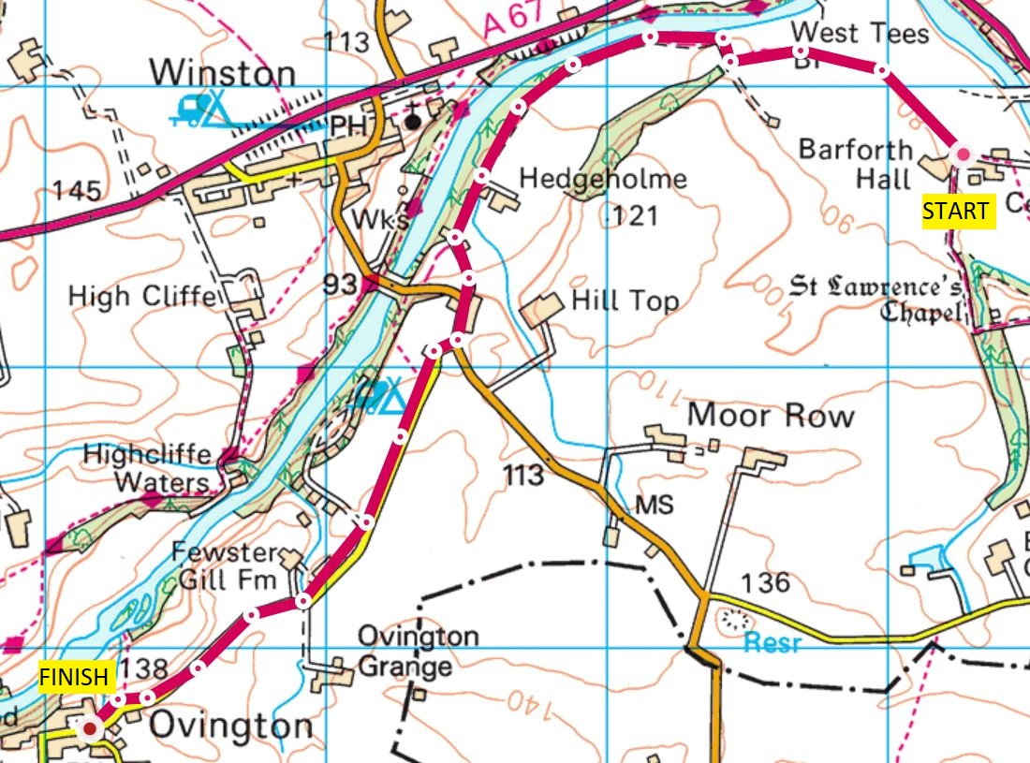
Look for alpacas and goats in paddocks on your right – not your every-day farm animals. Just after the cottage on the left there is a footpath. It starts off quite muddy/ wet before following around the left edge of some fields.

This path goes on for 1km until reaching a gate. Turn right and follow the rutted farm track. It takes you close to the river, following the wooded riverbank on your right and horse fields on your left.

You will see a footpath going straight on/ to the right at a farm building, but carry on along the road steep uphill to the left. As this curves round it brings you out next to a row of houses at Winston Gate.

Continue left along the road (don't turn right to go back down into Winston) and after 200m take the road to the right that leads to Ovington and the caravan park at Winston Bridge Riverside Retreat.

Carry on along the road for 2.5km. Be careful as there is no footpath and there are some sharp bends in the road, but fortunately the road itself is fairly quiet. You then come to the village of Ovington.

Ovington to Whorlton Bridge – 2 Miles
Refreshments: none
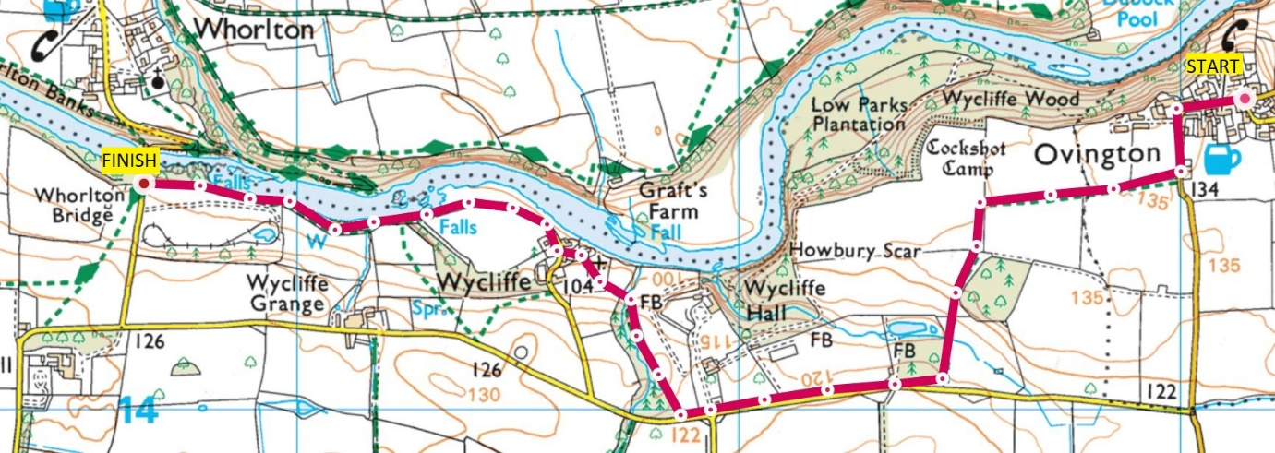
Carry on along the road that goes through the village. It has a nice village green with a maypole in the middle and the Four Alls Inn on the right. Towards the end of the village follow the road as it bends round to the left.

After 200m look for a fairly concealed footpath sign on the right. Cross over a stile to enter a field. This first field is lumpy underfoot - keep going straight ahead to reach a stile at the corner of the field. Across the stile and you head through a footpath cut into a crop field.

Carry straight on across the middle of this field until you come to a gap in the hedge at the end of the field.

Go through the gap and turn left, following the side of the next field, keeping the hedge to your left. You come to a stile and a gate - carry on through and follow the footpath signs and don't go down any tracks labelled "Private".

You'll go steadily downhill passing along some trees on the left and then the path swings to the right, following a dry-stone wall until you come to a stile that takes you over the wall.

Go down and up through the next field, passing woodland on your right and coming to a stile that brings you out onto a road.

Turn right and follow the road for 600m, passing the entrance to Wycliffe Hall. Look for a footpath sign on the right that goes into a small wooded valley. Follow this all the way to the bottom, and the path turns left and through a gate. You'll see a churchyard ahead. Go through the churchyard, keeping the church on your right. Go under a stone archway and you come out at the village of Wycliffe.

Turn right and follow the road. It is not a through-road but fine for pedestrians. After a while you'll pass a cottage on your right. The track narrows as it passes through trees, with the riverside on your right and scenic views of Whorlton Falls.

Go through a narrow stile and into a field. Again, keep close to the riverbank on the right (as close as permitted), and at the end of the field, go up some steps to come out on the road next to Whorlton Bridge.

At the time of writing unfortunately Whorlton Bridge is closed to all traffic as well as pedestrians, hopefully this will be remedied at some point.

Whorlton to Barnard Castle – 4.8 Miles
Refreshments: plenty of choice in Barnard Castle

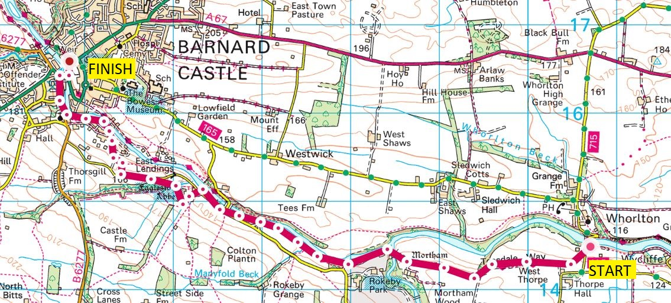

Turn right along the road and immediately look out for a signpost for the Teesdale Way on the right side of the road. Navigation is much easier for the next few miles as you are following the well signposted Teesdale Way.

The path cuts diagonally up through a field, and heads to a gate. Go through the gate and carry on along a stony path on the left side of a field. After the first field you pass a ruined farmstead on the right. Continue straight on along the next field, again it is bumpy underfoot. At the end of the field the path turns left and veers to the right round the edge of the field. Look for a gap in the hedge on your right and you'll see a gate and a sign.

Go through the gate and onto the top of a grassy field with wide views down to your right. Carry on along the top of this field, through another gate and then descend down towards a stone stile in the drystone wall at the bottom of the slope. You are now in the grounds of Mortham, with the handsome hall to your left. Follow the signposted Teesdale Way to the right until you reach the very scenic Meeting of the Waters.

Continue along the tarmac drive for 500m until you reach a road. At the road junction the Teesdale Way drops into the woodlands on the right. Follow this path through the woods with the river on your right for 1km until you see Abbey Bridge ahead. There is a steep climb through the woods that brings you out next to the bridge. Note: For the next section to Barnard Castle you are no longer following the Teesdale Way.

Don't go over the bridge, but take the road directly ahead that leads to Egglestone Abbey. Take a few moments to admire the Abbey whilst you are there. Keep the Abbey to your right, and then go right in front of some farm houses. After another 150m the path splits, you want to veer to the right through a field, leading to a road after a further 150m.

Follow the road for 200m and take a footpath on the right down through a field, heading left to reach a caravan/ holiday park. follow the road through the caravan park and there are a couple of footpaths that all take you to Startforth/ Barnard Castle. The riverside one is most scenic - I've highlighted this one on the map below with the alternatives in green.

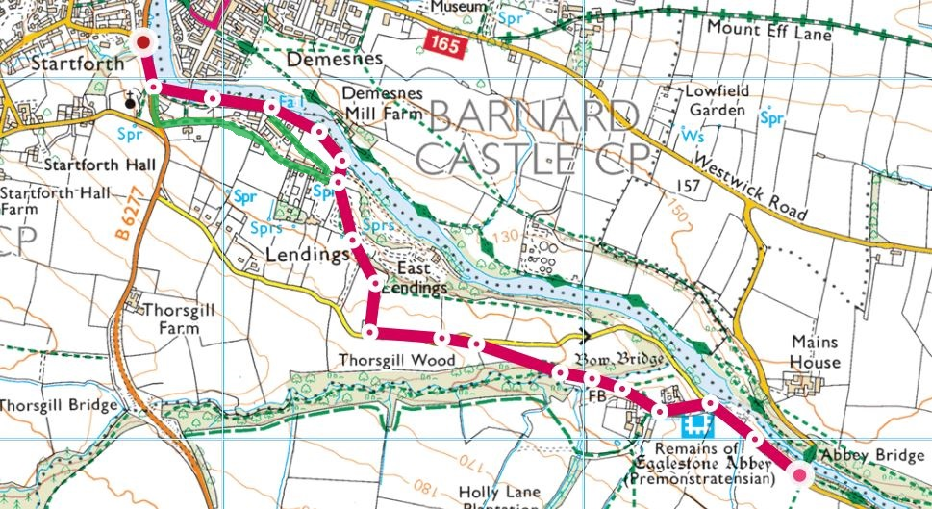

When you reach the road turn right along the road for 500m until you come to the road bridge at Barnard Castle. Go over the bridge and then take the footpath to the left that takes you up and around the castle. Once you are past the castle entrance, keep straight ahead and pass a church on your left to come out at a road in the centre of Barnard Castle.

Barnard Castle to Whorlton – 4.15 Miles
Refreshments: as above, lots to choose from in Barnard Castle

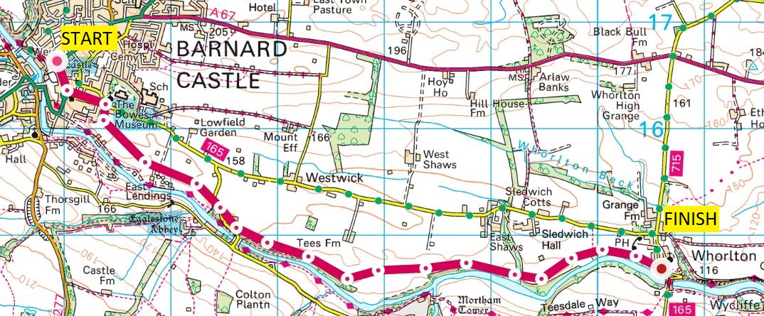

Turn right along Flatts Road. There are lots of bakeries and coffee shops as well as a Co-op so this is where you can stock up on supplies. Follow Flatts Road until you reach the iconic Buttermarket building and take Newgate road up on the left.

After you have passed Birch Road and St Mary's Church on your left, look for a road (Parsons Lonnen) on the right. Follow this down to the end and through the gate on the left to bring you out into an open field. Cross the fields in a roughly diagonal direction (south-east), downhill and with allotments to your right.

When you get to the bottom of the field there are two gates/ stiles and two options:

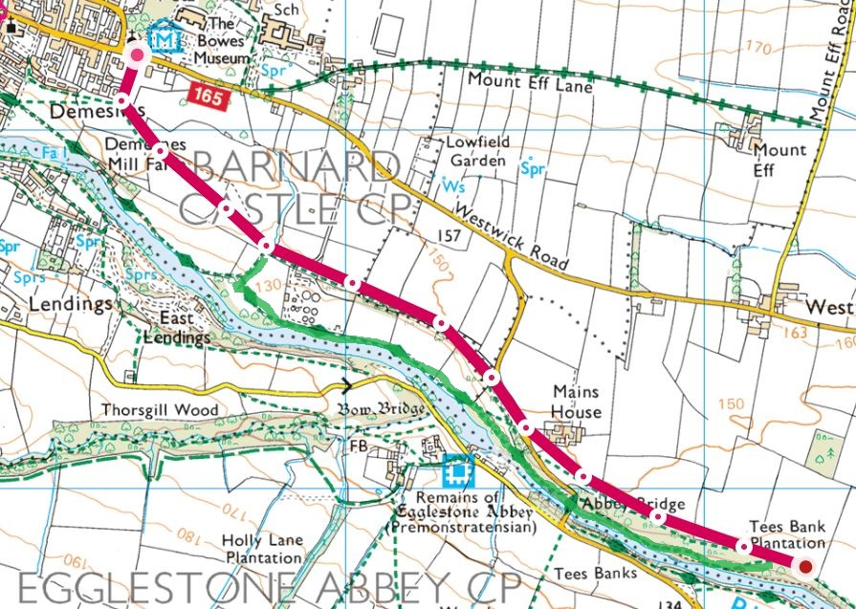

1. Follow the Teesdale Way to Abbey Bridge (marked green on the map)
Go through the gate on your right and ignore a gate to the left/ ahead. Take a footpath downhill and to the left, which brings you back down to the Teesdale Way. Follow this well waymarked path to Abbey Bridge.

Cross the road and carry on along the same side of the river, through woodland. The path follows the riverbank for another 250m before climbing up through the woods and emerging on the side of a field.

2. Take a higher path to Abbey Bridge (marked red on the map)
As you come down from Bowes Museum, don't take the path ahead, but look for a gate on your left. Go over a road leading to the waterworks and carry on along this path for 750m until you come to a road.

Turn right along the road (take care along the road) and look for a fairly inconspicuous stile in the wall on the right side of the road, just after a farmhouse. Carry on along this path as it climbs through the first field and you then have woodland to your right and the open field on the left. Continue for 750m, at which point the route described above joins this one.

After another 750m the footpath turns away from woodland and into open fields, and veers leftwards up through the field, crossing a beck near a tree. You then turn slightly to the right to aim for a stile and a drystone wall.

Once you are over the stile, follow the wall through the next field. At the end of the field, you go through another gate (or stile), and once again there are woods to your right above the riverbank. Here you have the option of a little detour (a short out and back) to the Meeting of the Waters viewing point.

Carry on for another 750m. Go through a gate and come out on a wooded ravine. Take a path to the right, not the one that heads to the left away from the river. Continue for another 1km along the path high above the riverbank until you reach Whorlton.

Whorlton to Winston – 3 Miles
Refreshments: none

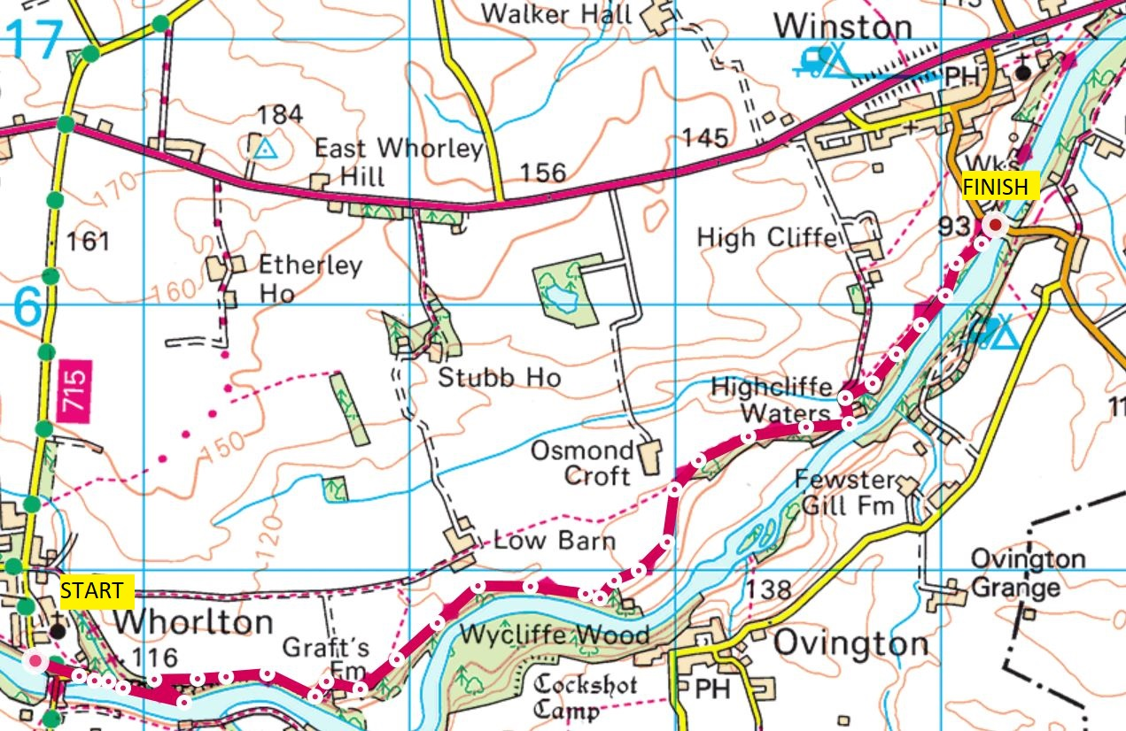

You join the road to Whorlton Bridge. Ignore the Teesdale Way sign to your right and carry on down the road ahead. When you come to a sharp bend in the road, take the footpath (Teesdale Way) straight ahead. The path follows the riverbank for 300m, including a steep up and down.

There is a sharp turn to the left, almost doubling back in yourself as you climb up and away from the riverbank. After 150m you will see a gate that leads out of the woods and into a field. Take this and turn right again to head in an easterly direction again.

After 500m, carry on along the path and cross a driveway that leads to a farm building in the woodland on your right.

After another 100m ignore a footpath on your left and keep along the edge of the woodland for another 1km. The path veers away from the river and comes out of the woodland into a field.

Keep to the top edge of the field, don't drop down the bank to the right. Carry on as the path turns into a farm track. When you reach a denser patch of woodland, look for a footpath sign and gate on the right hand side - this is before the farm ahead on your left. Take this path.

After 500m the track winds through a small holiday lodge park and over a road bridge. After the final building on your right, come off the road and onto a footpath (Teesdale Way) on your right. Follow this path for 1km as it meanders through woodland and open fields including a short steep climb to a stile. You come out at Winston Bridge. Go have a look at the spitfire sculpture on the bridge and read here about the reason why it is here: https://durhamcow.com/z-archive/winston-bridge/

Winston to Gainford – 2.75 Miles
Refreshments: shop in Gainford

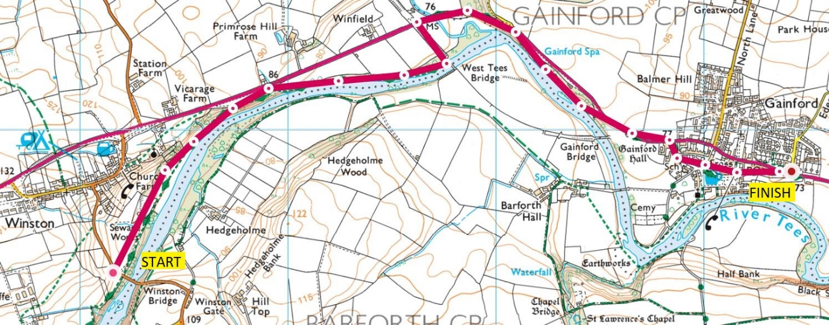

Cross the road at Winston Bridge and carry on the path opposite, still following the Teesdale Way signs. After 200m the gravel path veers to the right and you take the signposted path to the right that drops you down by the river.

Follow this path for 2km as it meanders up and down along the riverside, through woodland. Occasionally muddy and sometimes on boardwalks. You end up under the impressive West Tees bridge - look for steps up to get onto the bridge and then turn left (away from the river).

Continue along the disused railway path for 200m to reach the busy A67.

Turn right and follow the road for 1.5km to reach the village of Gainford. After passing farm buildings on the right, take the first road on your right - Low Road. Keep following Low Road round through the pretty village green.

If you need to stock up on supplies, there is a village shop back on the A67. Follow Low Road as it turns in to Low Green and then Tees View before rejoining the A67.
.

Gainford to Piercebridge – 2.45 Miles
Refreshments: shop at Gainford and farm shop at Piercebridge

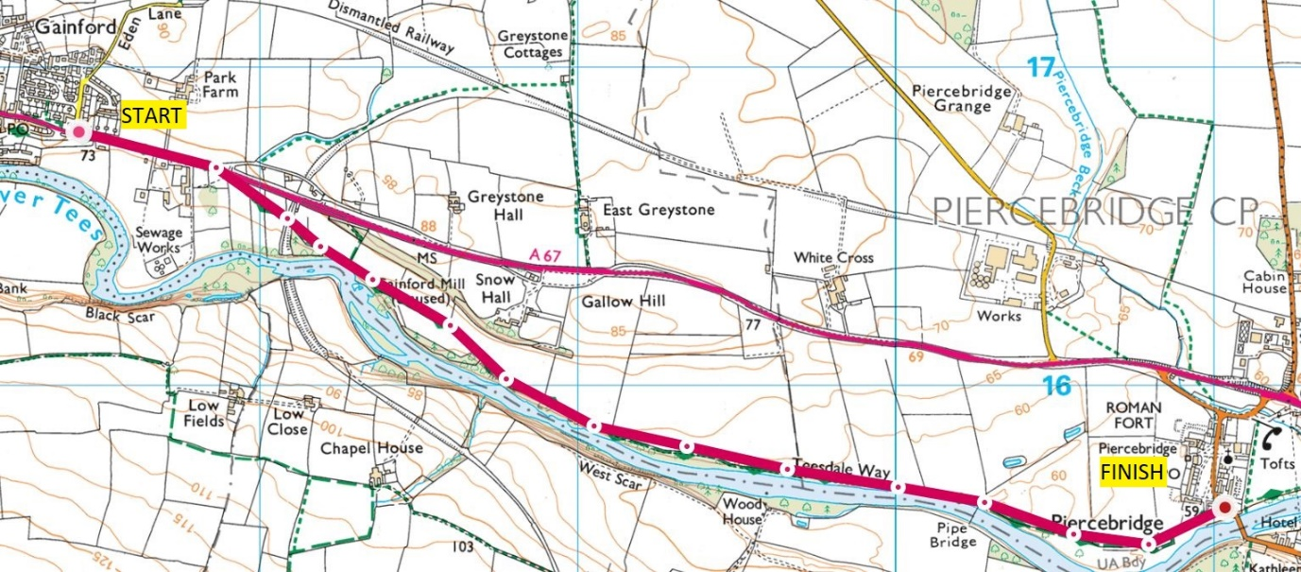

Follow the A67 for 300m, then look for a sign for the Teesdale Way on the right. Follow the path downhill and between a couple of paddocks before going under a disused railway bridge.

Then it couldn't be any easier - follow the path for 3km until you reach Piercebridge. The path comes out beside the road bridge over the river Tees, with the starting point 200m away.

Well done, you’ve completed the Barney Rumble!

